**Date: 18-01-2023**

Testing Date: 16th Mar’23

1. In Organization, Quotation, and Order section the address field name should be **“Name”** instead of **“Billing Name”**. - OK Done Found Fixed.
2. In Organization, Quotation, and Order section the Address input field should move below the **“Billing Name” –** OK Done Found Fixed.
3. Need to add **Category** & **Product/Project Interested** inside Opportunity section. **–** OK Also remove interested in field from Business partner. Pending – (Santanu Talk) Found Fixed.
4. Need to add a new option **~~Self Pick-up~~** in shipping type in Organization, Quotation, and Order section. “ExFactory” in DropDown Done Found Fixed.
5. Need an input field **Project Name & Location** in Order, and that same will be show in OPS. Rename Project location field as “Site Location” on OPS screen and print layout. Done **(Found Not Fixed in Detail Page).**
6. Tax in Item need to fetch from inventory & Keep **non-editable** while item selection for Quotation and Order. Rename Tax as GST% in Inventory and OPS screen, and Quotation & keep non-editable in OPS screen. Done Found Fixed.
7. Need to add a **Service tax** field below the Freight charges to calculate Service tax for charges like Installation Charges, Freight charges, Local charges. – OK – Field Name is GST% (Pending in pdf)

Also, Add Freight, Installation, Local charges field inside the Item selection in Order. Tax of 18% is fixed and mandatory on all the 3 – freight, installation and Local. Done (Pending in pdf) **(Found Not fixed).**

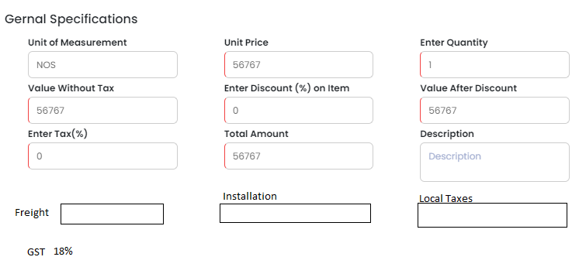

1. **[((Item x Qty)x Discount) x item Tax]** + **[((Installation x Item Qty) + (Freight X item qty) +(Local X item qty) x (Service Tax)]** = **Total**

The above formulation need to be implemented in Quotation and Order. OK Done **(Found Not Fixed in Detail & PDF Page).**

1. OPS print layout in 2 pages:- with Heading “Order Processing Sheet”.
2. 1st page: Client Details & Commercial (Pending in pdf)
3. 2nd page: Technical Details, Prepared By, & Checklist (Pending in pdf) **(Found Not Fixed in PDF Page).**
4. Need to rename the input field **Other Instruction** to **Billing Instruction** in OPS/Order. – Found Fixed.
   1. Under Order Information: Rename **Description** to **Client Details Remarks**: This will be mapped to an additional row which will be added under the contact details. The sales person filling the remarks / other instructions etc. should know exactly where it would be visible. Done (Pending in pdf) **(Found Not Fixed in Add Page).**
   2. Under Terms and Conditions: **Other instructions** field should be renamed to **Billing** **Instructions** that would be visible under Commercial Details: Billing and its clauses section. Right now it is show as “Any Other instruction” That would be renamed as Commercial Instructions” Done (Pending in pdf) Found Fixed.
5. Need of the new features like **Preview** and **Save as Draft** in Order. Pending (Backend Needed)
6. Need to remove Discount from item level Done (Pending in pdf)
7. OPS- Commercial Details: Billing & its Clauses refer to another sheet. (Pending in pdf)
8. Need to remove **“Mr. Anupam Joshi**” from Approved By in OPS Done
9. Employee ID not reflecting in OPS from Employee Module field name Employee ID. Refer to below screenshot. (Pending in pdf)

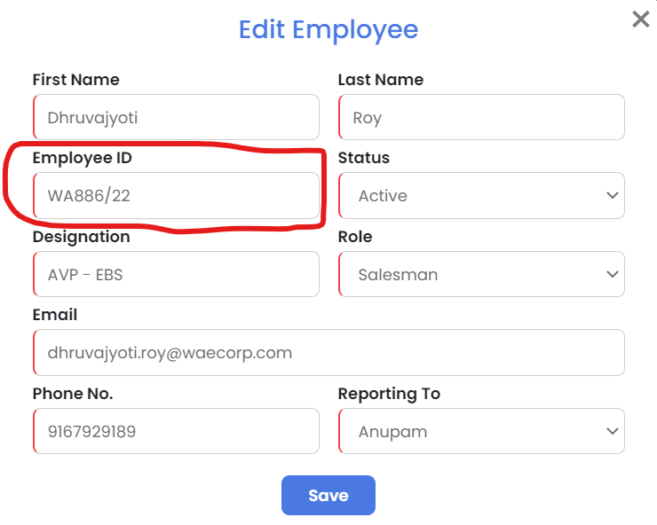

1. Need to replace the field **Client Name** to **End User Name** from OPS. (Pending in pdf)
2. Need to add a BP selection dropdown in Order form to show that in OPS’s **End User Name** (Pending in pdf)

The BP currently being selected is mapped to “Order From Name” in PDF of OPS.

The second BP field is to be mapped to “client name” in   
PDF of OPS and a corresponding contact person name also to be taken as input . This additional contact person name to be shown in the PDF of OPS. (add another row)

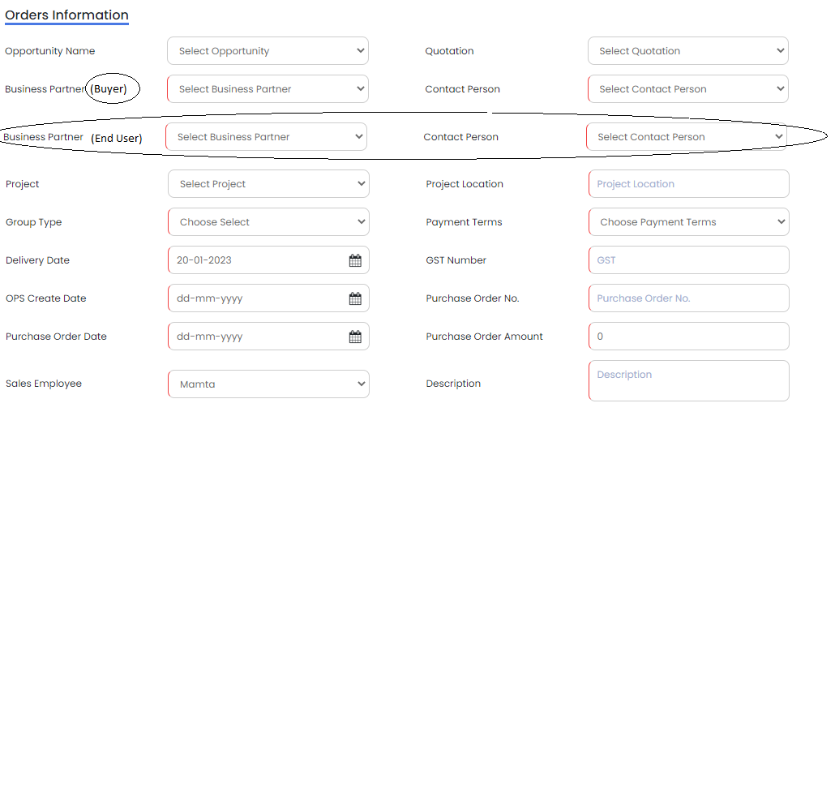

1. In OPS – PDF print: “Order From Name: to be changed to “Buyer” (Pending in pdf)
2. In OPS PDF print: “client name” to be changed to “End User” (Pending in pdf)
3. In Order >> New >> Select Item >> Machine specification – all fields of this has to be mandatory. Done
4. In Order >> New >> Select Item>> Machine Specification>>Solution Type>> Please use the below options in drop down: Done
   1. Sale
   2. Lease
   3. Demo
   4. Replacement
   5. Standby
   6. Donation
   7. FOC
5. Before saving the Order (OPS form) – Put a check: If Solution Type is Sale or Lease then the PO number and PO date is mandatory and it cannot take NA or Not available or Not applicable. Done
6. In Machine Specification (Item Edit in OPS)  
    a) Tap Qty – Data format Numeric Done

b) Tap Type – Add in drop down “NA” Done

c) Type of Machine – Add in drop down “RO+UV”, “RO+UF”, “UV+UF”, and “RO+UV+UF” Done

1. We need to capture more data on the order form but we do not need to print on PDF. We would need to view it on the screen only in the software. Pending (Backend Needed)

There would be two scenarios:

1. Where the sales person selects the project in the Order Form. In that case the information filled in the projects will automatically be carried forward here.
2. There is no entry of Project corresponding to that order. In this case all the fields will have to be selected manually (From list of Business partner and respective contact person)

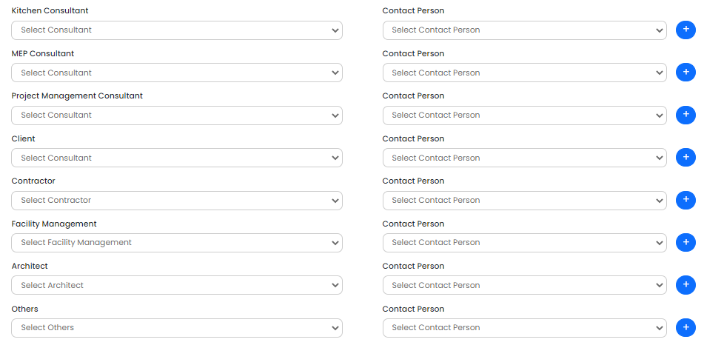Below are the fields. This data will be picked from Business partner and its respective contact person name.

1. OPS Heading should be in Dark not in light. Pending
2. More than 7% Discount Approval in Order. Pending (Backend Needed)
3. In Order Form: We need to take input for “Invoice To” Details. (This is needed when we need to send a copy of the invoice marking to a particular person in a particular office who would be responsible to release the payment)

Invoice To:

(These details are to be filled of the person who is responsible for accounting from buyer’s side and to process the balance payment)

Contact Person Name:

Contact Number:

Designation:

Email Id:

Address:

This would be visible as a separate row in OPS PDF as Invoice to:

Name, contact number, email id, designation. Done (Pending in pdf)

1. Freight Charges need a discount field and Need to show in details. @sriram
2. Installation charges a discount field and Need to show in details.@sriram
3. Need to add consulting fee on Order form, Details & OPS PDF. ok (Backend Needed)
4. Read Unread feature on Order section’s listing screen. The read unread interface should be responsive depending on each and every individual user. Ok (Backend Needed)
5. Need to add logic on the Employee Shivani Sharma (PPC Manager: New Role) to show all the Orders of WAE irrespective of hierarchy. Ok (Backend Needed)
6. Approval process needed. Clicking on the approval option Digital signature will attested on the OPS’s PPC Dept. Digital signature upload option In employee for this role. Ok (Backend Needed) –(Santanu Talk)
7. Need an Approval column in the Order Listing screen beside the status column. If approved show approved if not Show Pending at PPC. Ok (Backend Needed)
8. PPC Manager Can Approve and Reject OPS. So there should be status Pending, Rejected, and Approved. Ok (Backend Needed)
9. Once order approved by the PPC Manager role, Order cannot be cancelled. Once approved by the PPC Manager order cannot be rolled back. Ok (Backend Needed)
10. In OPS, in Technical Specifications section- Two Column merged with Add On (refer to OPS format): Multiple selection from Component Master List.

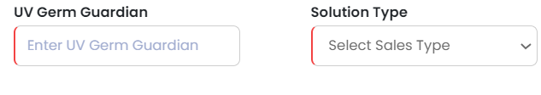Need to remove above column and add a Field Add-On with multi selection searchable dropdown. List of component name with price will show. Ok (Backend Needed)

1. “Solution Type” remove from Machine Specification, and move to Order Information screen while creating OPS. And Insert this field in OPS print layout on header as per OPS format. ok (Backend Needed)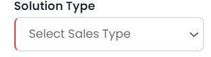
2. Mobile no./Land line length limit should be 15 digit ok Done (Backend Needed)
3. Zip code input field alpha numeric other than India ok Done (Backend Needed)
4. Machine specification dropdowns dynamic ok (Backend Needed)
5. Site Survey Serial No. Alpha Numerical Input in Order form (100 VarChar) ok (Backend Needed)
6. If an order approved by PPC Manager with Customer PO no. Again another order should not get created with same Customer PO no. ok (Backend Needed)
7. **Employee dropdown in Dashboard (Target vs Actual) Graph.** Ok (Done)